[Install and Configure Hybris 5.5 Commerce -- windows and linux](http://simplysach.blogspot.in/2016/03/install-and-configure-hybris-55.html)

***HYBRIS 5.5 BUILD & INSTALLATION STEPS (LINUX)***

**1)**      Unzip the downloaded hybris 5.x suite to the destination folder.

       (To unzip:  Unzip hybris-commerce-suite-5.5.0.0.zip –d  /var/www/html/Hybris E-Commerce)

**2)**       **Build the Hybris commerce suite**

a.       Navigate to : cd /var/www/html/Hybris E-Commerce/hybris/bin/platform

b.      **. ./setantenv.sh**    (. <space> ./setantenv.sh)

NOTE : If windows you can refer the link : <http://hybrisdiary.com/2015/09/26/installing-hybris-in-local-system/>

(If you encounter the following ERROR: [**ant build : unable to locate tools.jar. Expected find it in C:\Program Files\Java\jre7\lib\tools.jar**](http://stackoverflow.com/questions/21990123/ant-build-unable-to-locate-tools-jar-expected-find-it-in-c-program-files-jav)),

**you can just copy the tools.jar from "C:\ProgramFiles\Java\jdk1.7.0\lib" directly into "C:\Program Files\Java\jre7\lib\".You will successfully recover the problems.**

c.       **ant clean all**      (To build hybris)

d.      Press the Enter key to use the default, the develop configuration template. (may take appr 4-5 minutes with message(Refer below screenshot) :

**BUILD SUCCESSFUL**

**Total time: 2 minutes 5 seconds)**

**[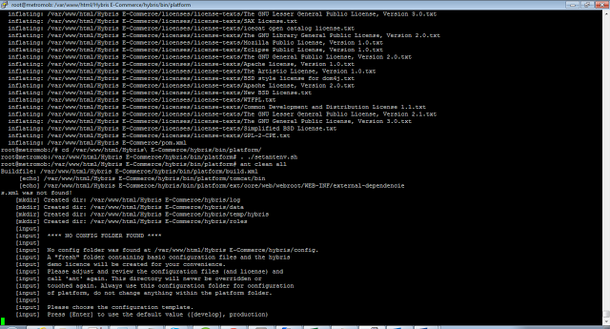](https://2.bp.blogspot.com/-BtI8CJXVSgY/Vt65nDcxD2I/AAAAAAAAGDY/ZJtPa51HaXU/s1600/hybr1.png)**

[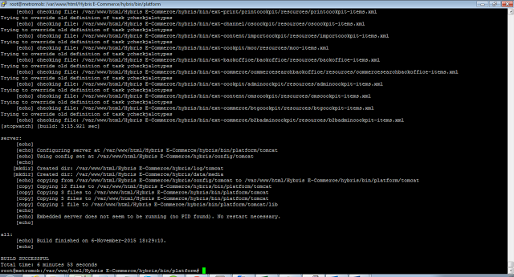](https://2.bp.blogspot.com/-VT6Vt2ulytE/Vt65-yYWYrI/AAAAAAAAGDc/QQn08cIicFA/s1600/h2.png)

***START HYBRIS***

**1)**      **Under the same path**

/var/www/html/Hybris E-Commerce/hybris/bin/platform

Type    ./hybrisserver.sh and Enter

(Note: In windows:  hybrisserver.bat debug)

**2)**      **Wait until Hybris starts and until the command shows:**

**Dec 12, 2014 3:39:08 PM org.apache.catalina.startup.Catalina start**

**INFO: Server startup in 163949 ms**

1)      Hybris is now ready to use:

Default url :  [http://localhost:9001](http://localhost:9001/)

[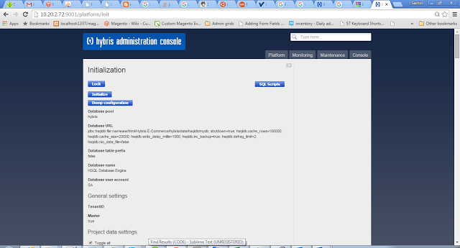](https://3.bp.blogspot.com/-1xYOnjXyOww/Vt66uk0kXTI/AAAAAAAAGDo/s3mzfnq3AIY/s1600/h3.png)

***CONFIGURE HYBRIS AS A SERVICE – To auto start hybris on boot***

1)      Stop the server:                **./hybrisserver stop**(or ctrl –c   exit)

2)      Create a hybris service startup file:    vi /etc/init.d/hybris

a.       Setting the base path in the file to your hybris installation:

                        HYBRIS_HOME="/var/www/html/Hybris E-Commerce/hybris" and save the file.

|  |  |
| --- | --- |
| b.    If error is thrown in this line: accepted | # Source function library  . /etc/init.d/functions |

Replace with:                            # Source function library

                        . /lib/lsb/init-functions

c.       Set permission for the file to be executed:

**chmod 755 /etc/init.d/hybris**

**3)**      **Add the file to the server startup list:**

chkconfig --add hybris

chkconfig hybris on

**4)**      **To rebuild hybris :**

cd /home/hybris/hybris/bin/platform

                                                         . ./setantenv.sh

ant clean all          # command to rebuild

NOTE: To upgrade higher ANT version:

i)                    Download “**apache-ant-1.9.6.zip**” and extract to /usr/local

ii)                   Under hybris/bin/platform:

[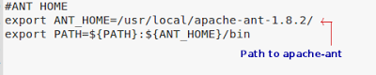](https://4.bp.blogspot.com/-WR65XS5AmAs/Vt67cNRzuvI/AAAAAAAAGD0/nkdeBJHGoQo/s1600/h4.png)

iii)                 To check version of ant:  **ant -version**

5)      Start Hybris server:             **./hybrisserver.sh run**

**Hurray HYBRIS is now ready to RUN!!!**

**Default localhost:**              **http://<localhost>:9001**

**Default Factory password:**

**User:         admin**

**Password: nimda**

[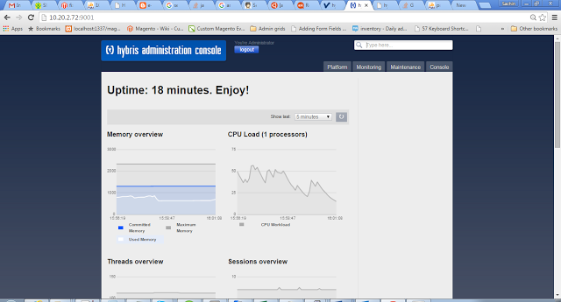](https://3.bp.blogspot.com/-F6gL6fWoMPc/Vt68m5c9_oI/AAAAAAAAGEA/uZU-MhfLhIs/s1600/h5.png)

**http://<localhost>:9001/mcc**

[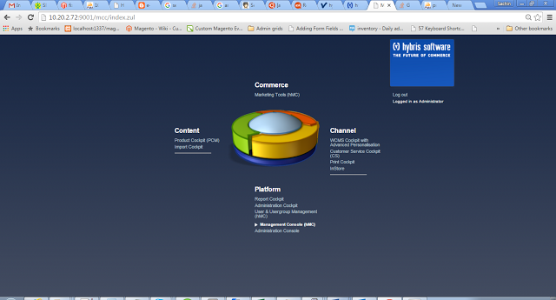](https://4.bp.blogspot.com/-vZ7uMmqK--w/Vt69RP6WPLI/AAAAAAAAGEI/D038ZWMjKSI/s1600/h6.png)

**http://<localhost>:9001/admincockpit**

[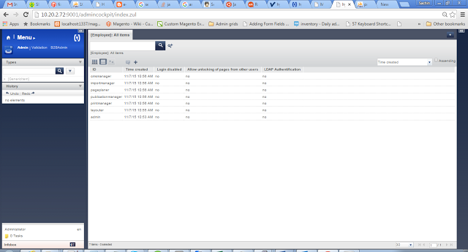](https://3.bp.blogspot.com/-yDaGGCwXgHg/Vt69RkzC1XI/AAAAAAAAGEM/YWji4JXwsaY/s1600/h7.png)

**To install/save Custom extensions in a separate directory.**

**In localextensions.xml**

<extension>

    <!--

    There should be a path dir defined within the config like below

  -->

    <path dir="${HYBRIS_BIN_DIR}" />

    <!--

    Navigate to where your extensions are defined, you can create your

    own path variable above if you want too, this is just an example for you  -->

  <extension name="${HYBRIS_BIN_DIR}/../../myExtensionsFolder/extension1" />

  <extension name="${HYBRIS_BIN_DIR}/../../myExtensionsFolder/extension2" />

</extension>